**Ministry of Health**

**Malawi Paediatric**

**Non-Communicable Diseases Management Guidelines 2025**



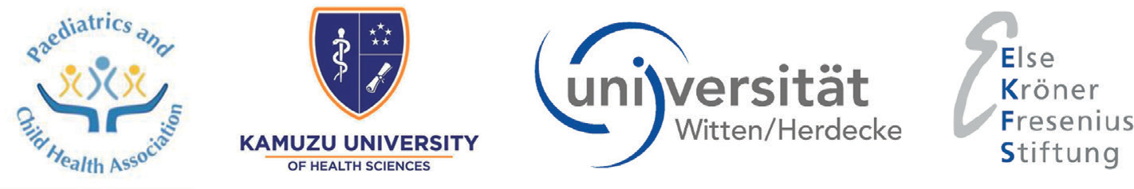

**FOREWORD**

Malawi has adopted the life course approach to health in the Health Sector Strategic Plan III and the child health strategy. This approach looks beyond the traditional causes of under-five mortality which are mainly infectious diseases extending to children aged nineteen years where non-communicable diseases (NCDs) are an important cause of morbidity and mortality.

Malawi’s Package of Essential Non-communicable Disease Interventions-Plus (PEN-Plus) operational plan outlines the pathway for improving the diagnostics and management of NCDs in Malawi. It has however recognised the urgent requirement to address the unique needs and approach required to improve the management of paediatric NCDs. Some of the important common NCDs include chronic respiratory conditions like asthma, cardiovascular diseases like congenital heart disease and rheumatic heart disease, neurological conditions like epilepsy, sickle cell disease and renal diseases. Despite recognition of the problem posed by these non-communicable diseases, most health workers and health facilities may not be adequately prepared to manage children who present with non-communicable diseases mainly because of lack of human resources, knowledge, skills and supplies required to manage these patients.

In order to improve the provision of quality health care in children presenting with NCDs, the non- communicable disease treatment guidelines have been developed by experts both nationally and reviewed by international experts to aid health workers in managing such conditions. The guidelines are tailored towards helping health workers at various healthcare levels in Malawi including primary, secondary and tertiary care levels. They also include promotion and preventive messages where applicable.

The NCDs treatment guideline for children is aligned with the Child Health Strategic Plan and Health Sector Strategic Plan III priority 1, priority 4 and priority 6. The guidelines will ensure that all paediatric patients access quality equitable health care provided by knowledgeable and skilled professionals regardless of the level at which they access the care. The guidelines will also be accessed by an interactive application which will increase accessibility of the information by health professionals who manage these children.

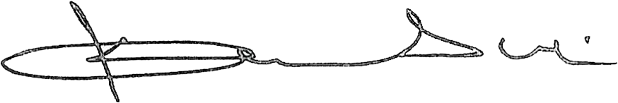

Honourable Khumbize Kandodo Chiponda, MP

**MINISTER OF HEALTH**

**Acknowledgements**

The Ministry of Health would like to acknowledge all stakeholders who participated in the development of these non-communicable disease guidelines for children in Malawi. The process involved countless meetings and workshops by different experts in paediatrics. The work of the external reviewers who committed their time to review the guidelines is highly appreciated.

The Ministry of Health expresses its sincere gratitude to Else Kröner-Fresenius-Stiftung for its financial support through Witten/Herdecke University, Germany and Paediatric and Child Health Association of Malawi under the Else Kröner Malawi Child Health Programme. The commitment and dedication of the members of the Paediatric and Child Health Association of Malawi and experts in different fields is highly appreciated.

In a special way, the Ministry would like to thank Dr Yamikani Chimalizeni and Dr Jonathan Chiwanda Banda who provided overall leadership. We are grateful to Prof Elizabeth Molyneux, Prof Ralf Weigel and PD Dr Carsten Krüger for their technical advice. The following people provided leadership in various chapters to ensure successful completion of the guidelines, Dr Emmie Mbale, Dr Kondwani Kawaza, Dr Mercy Kumwenda, Dr Jessica Chikwana, Dr Ajib Phiri, Dr Amos Msekandiana, Dr Frank Phoya, Dr Dominic Moyo, Dr Takondwa Chimowa, Dr Jenala Njirammadzi, Dr Elizabeth Nkosi, Dr George Chagaluka and Ms Sunganani Manjolo. The other members of the team that participated in the development of the guidelines include, Dr Tisungane Mvalo, Dr Alex Zumazuma, Dr Gugulethu Mapurisa, Mrs Mphatso Nawena, Dr Stella Wachepa, Dr Watipaso Kalizang’oma, Dr Prisca Harawa, Dr Rizine Mzikamanda, Dr Beatrice Chikaphonya Phiri, Dr Ethwako Phiri, Dr Layla Banda and Dr Jessica Chaziya.

The Ministry is further grateful to the following external reviewers; Dr Amy Sanyahumbi, Dr Antke Züchner, Dr Judith Lindert, Dr Sarah Loetz, Dr Trijn Israels, Prof Neil Kennedy, Dr Ute Muhitira, Prof Peter Höger, Prof Hans-Iko Huppertz, Dr Rachel Mlotha-Mitole, Dr Lawrence Mubaiwa, Prof Melissa Gladstone and Dr Thembi Katangwe.

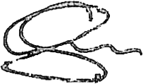

Dr. Samson Mndolo

**SECRETARY FOR HEALTH**

**List of contributors**

The Ministry of Health acknowledges contributions from the following individuals:

**Kamuzu University of Health Sciences:**

Dr Ajib Phiri, Paediatrician

Dr Dominic Moyo, Paediatrician Dr Emmie Mbale, Paediatrician

Dr Jenala Njirammadzi, Paediatric Intensivist

Dr Josephine Langton, Paediatric Emergency Medicine Specialist Dr Kondwani Kawaza, Neonatologist

Dr Prisca Harawa, Paediatric Registrar

Dr Yamikani Chimalizeni, Paediatric Cardiologist

**Queen Elizabeth Central hospital:**

Dr Beatrice Chikaphonya Phiri, Paediatric Haematologist-Oncologist Dr Frank Phoya, Paediatric Rheumatologist

Dr George Chagaluka, Paediatric Haematologist-Oncologist Dr Ethwako Phiri, Paediatric Nephrologist

Mphatso Nawena, Clinician

**Zomba Central hospital:**

Dr Jessica Chikwana, Paediatrician

Dr Takondwa Chimowa, Developmental Paediatrician

**Kamuzu Central Hospital:**

Dr Amos Msekandiana, Paediatric Endocrinologist Dr Elizabeth Nkosi, Medical Officer

Dr Jessica Chaziya, Paediatrician Dr Mercy Kumwenda, Paediatrician Sunganani Manjolo, Clinician

**Baylor Children’s Foundation, Malawi:**

Dr Rizine Mzikamanda, Paediatric Haematologist -Oncologist Dr Watipaso Kalizang’oma, Paediatric Registrar

Dr Stella Wachepa, Paediatrician

**University of North Carolina (UNC – Lilongwe):**

Dr Tisungane Mvalo, Paediatrician

**Internal and external reviewers**

**Kamuzu University of Health Sciences:**

Prof Elizabeth Molyneux, Paediatric Emergency Medicine Specialist Dr Trijn Israels, Paediatric Oncologist

**Baylor College of Medicine:**

Dr Amy Sanyahumbi, Paediatric Cardiologist

**Witten/Herdecke University, Germany:**

Prof Ralf Weigel, Paediatrician

PD Dr Carsten Krüger, Neonatologist/ Gastroenterologist

**Germany:**

Dr Antke Zuchner, Paediatric Cardiologist

Dr Judith Lindert, Paediatric Emergency Medicine Specialist Dr Sara Loetz, Paediatrician

Dr Ute Muhitira, Paediatric Endocrinologist

Prof Peter Höger, Paediatric Rheumatologist/Dermatologist Prof Hans-Iko Huppertz, Paediatrician

**University of Kwazulu-Natal:**

Dr Lawrence Mubaiwa, Paediatric Neurologist

**University of Witswattersrand:**

Dr Rachel Mlotha-Mitole, Paediatric Gastroenterologist

**University of Cape Town:**

Dr Thembi Katangwe-Chirwa, Paediatric Neurologist

**Queens University Belfast:**

Prof Neil Kennedy, Paediatrician

**United Kingdom:**

Prof Kevin Morris, Paediatric Intensivist

**University of Liverpool:**

Prof Melissa Gladstone, Developmental Paediatrician

**Editorial team**

Dr Ajib Phiri, Dr Amos Msekandiana, Dr Emmie Mbale, Dr Frank Phoya, Dr Jessica Chikwana, Dr Kondwani Kawaza, Dr Mercy Kumwenda, Dr Takondwa Chimowa, Dr Yamikani Chimalizeni

**Cover Design:** Chilemba Communication Consultants

**Book design and Layout:** Noordin Cassim (Artlab Image Solutions)